Various aspects of project planning and execution are incorporated as different users:-

1. **Engineer**:- Activities of an engineer can both be reserved by the engineer and by the supervisor (Team Lead). An Engineer is able to view, reserve and filter its activities.
2. **Team Leader**:- Team Leader has the responsibility as an engineer and as a supervisor. Team Leader has all the functionality of an engineer and can supervise on other engineer.
3. **Manager**:- Manager is able to view various activities of Engineer/Team Leader and applying filters to it.

**Engineer**

1. Book Activities

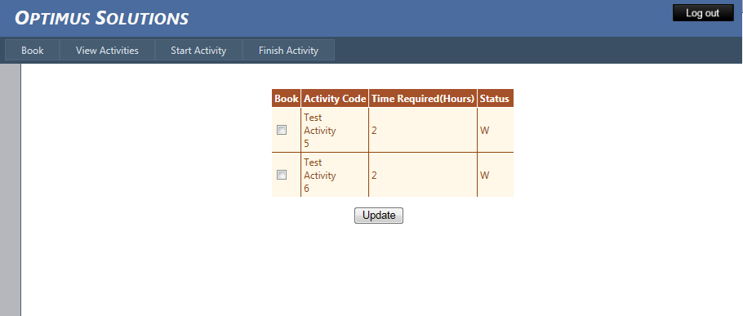

Engineer can view various activities which are waiting to be booked.

Appropriate options can be selected in the checkbox and can be booked.

1. View Activities

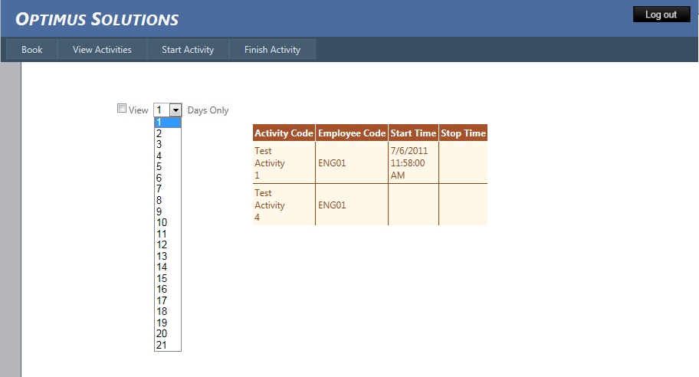

View activities which are either booked/started/finished by the engineer.

Various time frame window i.e. 1 day,2 day, can be selected to view activities started in that time frame.

1. Start Activities

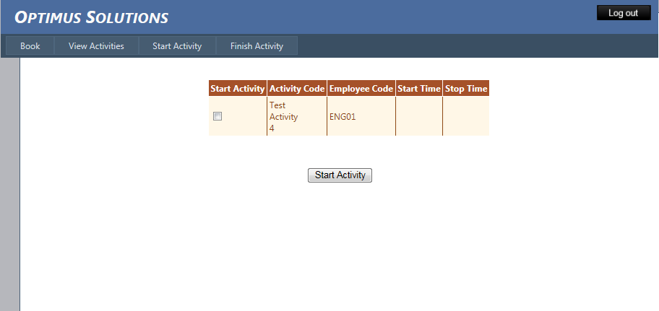

Start Activity which are booked by the engineer.

1. Finish Activity

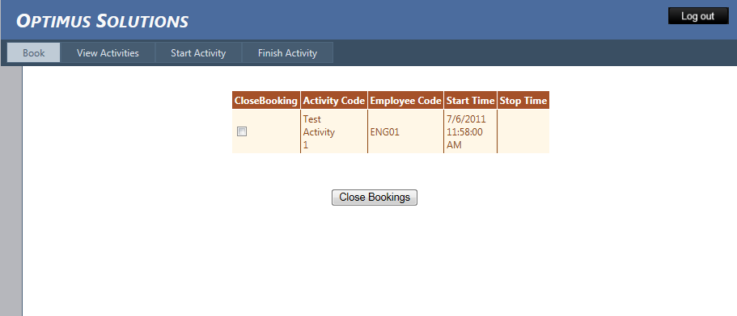

Activities which are opened by the engineer can be finished with this option.

**Team Leader**

1. Book Self

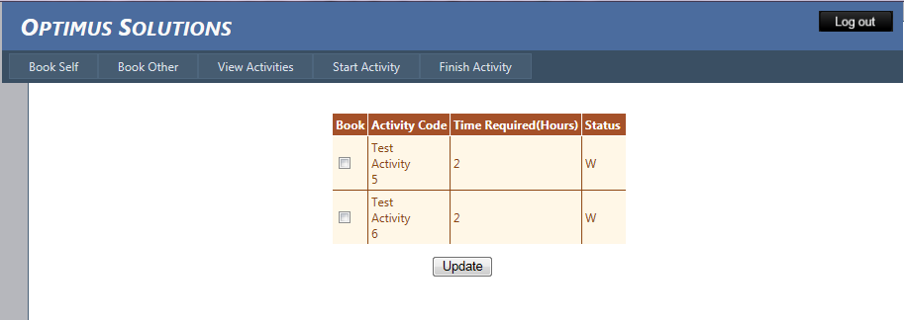

Booking activities for self.

1. Book Other

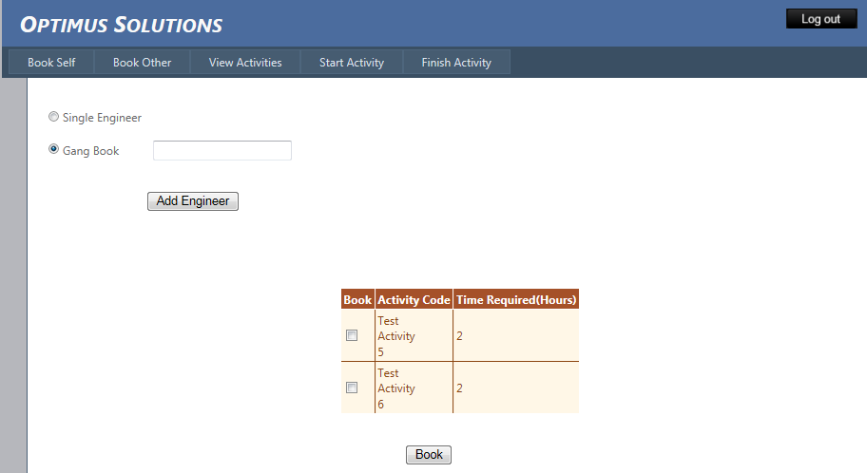

Booking Activities for other engineer. Group booking can be done by making groups of engineer.

1. View Activities

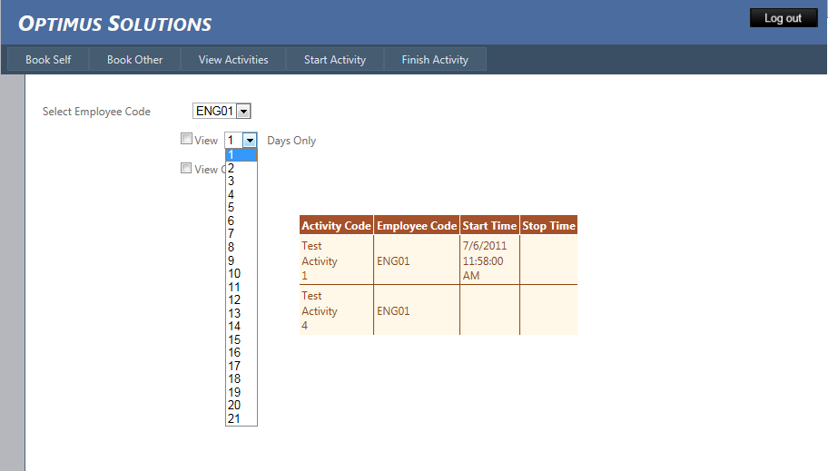

Viewing activities for various engineer with their employee code from drop down.

Custom filters like viewing in a time frame, viewing self or others.

1. Start Activity

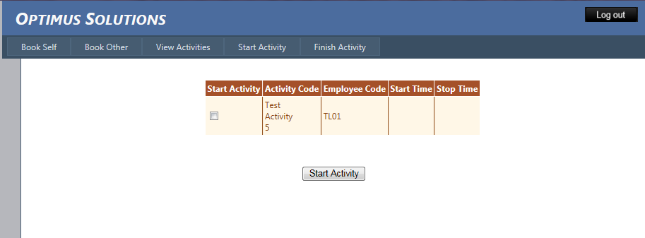

Starting self activity

1. Finish Activity

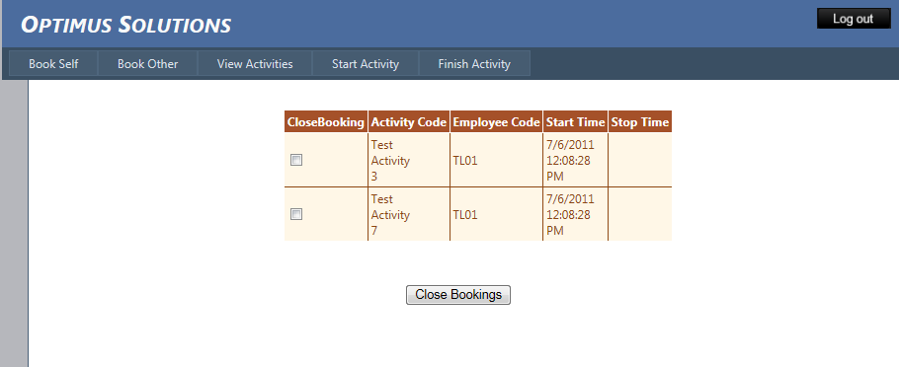

Finish self started activities.

**Manager**

View Activities

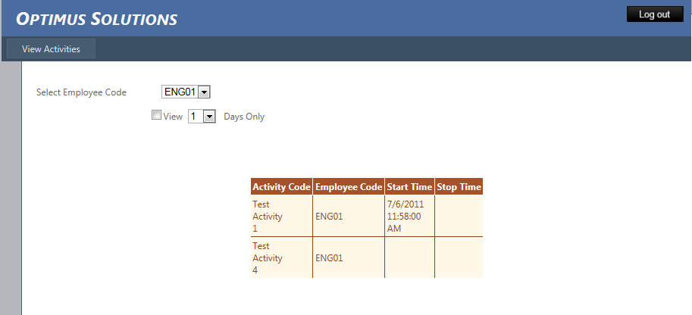

Viewing activities by applying employee code and duration window.